Q. Write a simple code for creating a login with username and password.

As soon as the password is correct it should display welcome note.

Prepare test cases for the following

1. To test the password using Boundary Value Analysis, Equivalence Partitioning Method. Create domain constraints yourself.

2. Find the cyclomatic complexity of the code.

3. Calculate statement coverage and Branch Coverage

Simple Login UI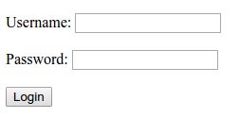

IFlowchart for checking of password length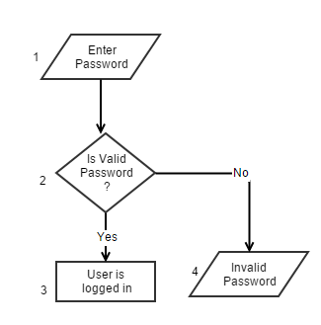

|  |  |
| --- | --- |
| **Boundary Value Analysis (Domain 6 – 12)** | |
| Password Length | Valid |
| 5 | FALSE |
| 7 | TRUE |
| 9 | TRUE |
| 11 | TRUE |
| 13 | FALSE |

|  |  |
| --- | --- |
| **Equivalence Partitioning Method (Domain 6 – 12)** | |
| Password Length | Valid |
| 5 | FALSE |
| 9 | TRUE |
| 13 | FALSE |

**Cyclomatic Complexity Calculation:**

|  |  |
| --- | --- |
| Edge (E): | 3 |
| Node (N): | 4 |
| Exit Points (P): | 2 |
| Cyclomatic Complexity (V=E-N+P): | 1 |

**Test Cases:**

|  |  |  |  |
| --- | --- | --- | --- |
| S.N | Test cases | Statement Covered | Branch Covered |
| a | 1—2—3 | 3 | 1 |
| b | 1—2—4 | 3 | 1 |

**Statement Coverage Calculation:**

Total Statement = 4

|  |  |
| --- | --- |
| Test Case | Statement Coverage |
| a | 75.00 |
| b | 75.00 |

**Branch Coverage Calculation:**

Total Branch = 2

|  |  |
| --- | --- |
| Test Case | Branch Coverage |
| a | 50 |
| b | 50 |